Press Release

TigerPress Invests in New Koenig & Bauer Duran Allpro 110 Folder Gluer
  - Leading commercial and packaging printer sees increased opportunity to maintain fast growth

- New folder gluer will boost productivity by 30% in its post press department
- Speed, efficiency, and productivity of Koenig & Bauer Duran Allpro folder gluer will replace two older machines
- The Massachusetts printer continues to grow posting double digit sales growth three years in a row

Dallas, 11.05.2020
In today’s evolving business environment, successful corporate owners need to make decisive moves in unison with the marketplace. Jennifer Shafii, CEO of TigerPress, can be counted among these visionary owners. As the printing industry has shifted, Shafii recalibrated her East Longmeadow, MA business from primarily a commercial shop to a custom packaging and digital printing producer with an emphasis on green technology. Under her watch, the firm has posted double digit sales growth three years in a row and foresees further growth this year.
To keep the momentum going as it shifts to increase its packaging sales, Shafii continues to make major capital improvements each year to its 100,000 sq ft manufacturing facility. This year, TigerPress eagerly awaits a new Koenig & Bauer Duran Allpro folder/gluer in early 2020.
Finishing capabilities
“We’ve purchased the new folder gluer to help us keep up with our growth and increase our productivity,” says Shafii. “We’re always addressing our customer’s needs with faster turnaround and the folder/gluer will be key to those requests. Currently we have five folder/gluers at our facility and we believe we can replace one or even two of them with our new Omega Allpro, due to its very quick makeready and extremely high quality production.”
Shafii says that she was searching for a new folder/gluer and the Koenig & Bauer Duran Allpro caught her eye. As her firm gains more custom packaging work, she needed a folder/gluer that would handle a wide range of substrates from cartonboard to corrugated, would offer versatility and the capability of producing the most complex range of carton styles. Allpro folder/gluers produce straight line, double wall, crash lock and optional four- and six- corner with single finger servo fold for high speed precision as well as inner partition, Z-fold, conical crash lock and CD boxes at a maximum belt speed of 400 m/ min. Operators at TigerPress will appreciate the Omega’s touch screen control panels, and modems for diagnostic purposes that are designed for strength and reliability.
“We eagerly anticipate the arrival of the Koenig & Bauer Duran Allpro folder/gluer,” says Shafii. “It demonstrates our strong commitment to providing the highest customer satisfaction with the latest state-of-the-art equipment. Our goal is to continue our strong growth and to provide outstanding quality and unique production techniques including special finishing for our customers.”
Reza and Jennifer Shafii opened their first quick print shop in 1985. Within a few years the business grew from one store to multiple locations around western Massachusetts. In 1997 they established TigerPress as their commercial printing division. With dedication to quality and customer service, TigerPress grew rapidly. Today, TigerPress is a sustainable eco-friendly printer, using green technology and operating in a 100,000 sq. ft. manufacturing plant in East Longmeadow, Massachusetts. The state of the art manufacturing facility offers digital printing, commercial printing, and custom package printing all under one roof, powered by 2500 solar panels. TigerScorecard, Supermodels Unlimited Magazine, TigerBooks, and TigerPress Online are all divisions of TigerPress.
Interesting website: www.tigerpress.com
Photo 1:
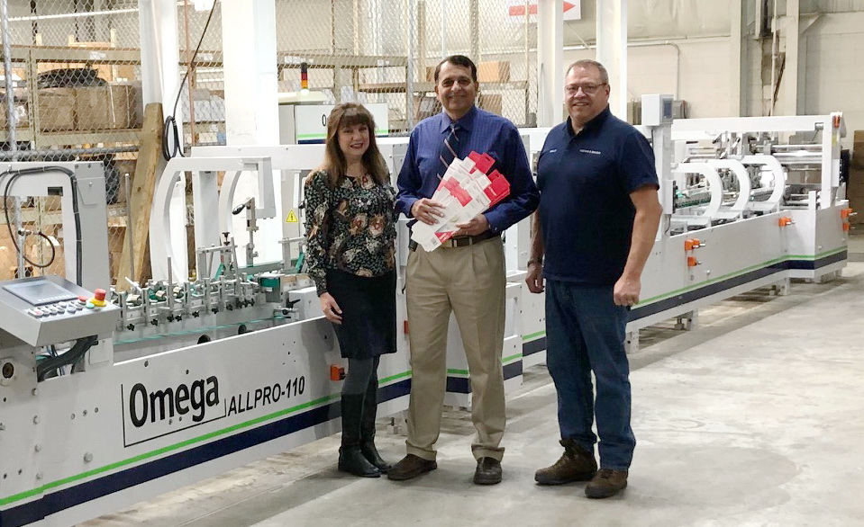

Left to right: Jennifer Shafii, CEO of TigerPress; Reza Shafii, president of TigerPress; meet with Walter Nickerson, Koenig & Bauer project manager-Duran at the East Longmeadow, MA facility.
Press contact
Koenig & Bauer (US/CA)
Eric Frank
T : 469.532.8040 or 800.532.7521
M eric.frank@koenig-bauer.com

About Koenig & Bauer
Koenig & Bauer (US) is located in Dallas, Texas and a member of the Koenig & Bauer Group, which was established over 200 years ago in Würzburg, Germany. Koenig & Bauer’s claim, “We’re on it.” gets to the heart of Koenig & Bauer’s values and competencies for all target groups. The group's product range is the broadest in the industry; its portfolio includes sheetfed offset presses in all format classes, post press die cutting, folder gluers, inkjet presses and systems, flexographic presses, commercial and newspaper web presses, corrugated presses, special presses for banknotes, securities, metal-decorating, glass and plastic decorating.

Further information can be found at www.koenig-bauer.com

