Press Release

Koenig & Bauer Maintains Leadership Position in the Global Corrugated Board Market with Launch of CorruCUT Sheetfed Flexo Press and Die Cutter
  - Excellent print quality, waste reduction, and increased efficiency draw praise from the market

- Leading corrugated packaging firm is first to install the new CorruCUT
- Unique features such as a vacuum-belt feeder without infeed shaft, a new solution for anilox roller exchange, and an overhead vacuum delivery are included
- Strong durable side frames made from cast iron poured to shape at 1300 °C at the foundry display almost no vibrations
Dallas, 28.01.2020
Koenig & Bauer is maintaining its leadership position in the growing global corrugated board market with the launch of the CorruCUT, a new sheetfed flexo press designed for the large and high growth market for direct printing on corrugated board.
“Corrugated customers are seeking machines with faster setup and more automation as well as tailor-made solutions for their specific environment,” says Jeff Dietz, vice president of the Web & Specialty Press Division at Koenig & Bauer (US). “Waste handling in the corrugated process is a big concern as is color consistency and repeatability for brands. We believe the new CorruCUT will satisfy the needs of printers who require high graphic corrugated printing and converting machines that are faster and more cost efficient to operate. Our CorruCUT flexo press will enable us to further consolidate our strong position in the growing packaging market.”
The sheetfed flexo CorruCUT press is designed with extremely robust mechanical engineering paired with maximum ease of operation and maintenance. Its strong durable side frames are made from cast iron poured to shape at 1300 °C at the foundry, which display almost no vibrations. It unites proven technology with modern electronics and intelligent automation, establishing a high performance production tool geared to all current demands of the corrugated industry. By virtue of its printing and diecutting quality, the short makeready times and general operating comfort, this new innovation with a spectacular design has generated a very positive response from customers and the global corrugated board industry.
The CorruCUT incorporates a number of unique features such as a vacuum-belt feeder without infeed roller, a new solution for anilox roller exchange, and an overhead vacuum delivery. The CorruCUT handles corrugated sheets with a width of up to 110 inches and a thickness of 0.354 inches, running at speeds up to 12,000 sheets per hour. Koenig & Bauer engineers have designed it with DriveTronic shaftless drives that allow the demands of high precision multicolor flexo post-printing to be easily achieved. It allows operators to set up while production is running and affords fast job change and low-maintenance. It provides operators with integrated error diagnostics and online remote maintenance. Users control the machine with a flexible Profibus system and easy-to-use ergonomic touchscreen. Its open-architecture design permits access to the printing units for setup while the current production continues. Its production management system permits the saving of repeat jobs and the automatic presetting of job parameters. The integrated error diagnostics and online remote maintenance also surpass general standards.
Sheets are carried in exact register from the feeder, via the printing units to the rotary die-cutter by way of a continuous overhead vacuum transport system. The direct drive technology also allows the use of different printing plate thicknesses by compensating the circumferential speed of the cylinder. The CorruCUT printing units are fitted with the proven quick-clamp chamber blade system made from carbon fiber composite. The low volume of the chamber blade serves optimum ink transfer and minimal ink losses during washing. The ink supply and the automatic washing system are designed to achieve the best possible results with low water consumption and fast washing times.
The prestigious Klingele Group is the first customer to install the new CorruCUT sheetfed flexo press with integrated high board line rotary die-cutter at its German box plant. In developmental partnership with Klingele, the new press has been designed for the high-performance rotary production of die-cut corrugated products in ultimate flexo post-printing quality. The Klingele six-color press is a completely new design – from the feeder, via the printing units and rotary die-cutter to the delivery. Due to the high quality of the CorruCUT’s printing and diecutting, its short makeready times and general operating comfort, the new machine has generated a very positive response from Klingele and the global corrugated board industry.
Photo 1:
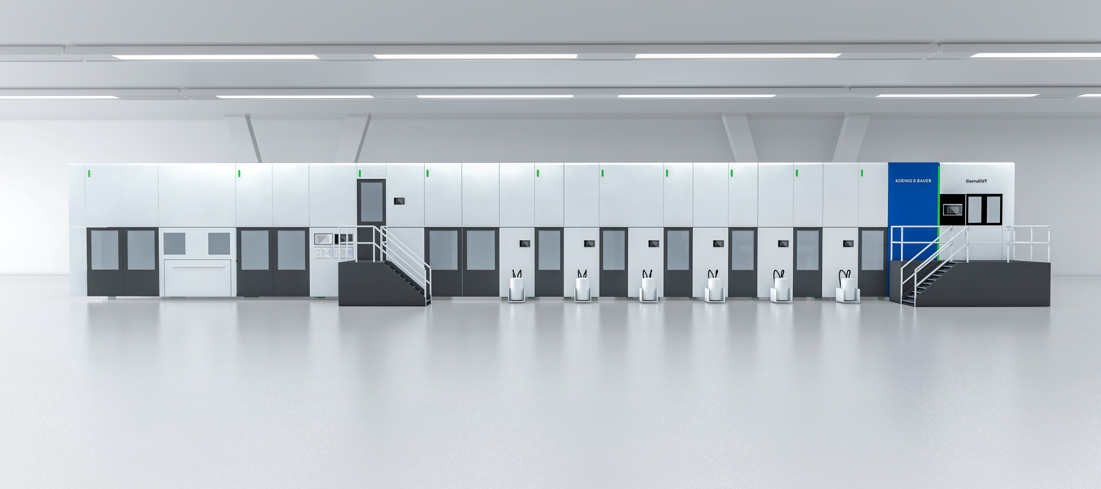
CorruCUT is a sheetfed flexo press with integrated high board line rotary die-cutter.

Press contact
Koenig & Bauer (US/CA)
Eric Frank
T : 469.532.8040 or 800.532.7521
M eric.frank@koenig-bauer.com

About Koenig & Bauer
Koenig & Bauer (US) is located in Dallas, Texas and a member of the Koenig & Bauer Group, which was established over 200 years ago in Würzburg, Germany. Koenig & Bauer’s claim, “We’re on it.” gets to the heart of Koenig & Bauer’s values and competencies for all target groups. The group's product range is the broadest in the industry; its portfolio includes sheetfed offset presses in all format classes, post press die cutting, folder gluers, inkjet presses and systems, flexographic presses, commercial and newspaper web presses, corrugated presses, special presses for banknotes, securities, metal-decorating, glass and plastic decorating.

Further information can be found at www.koenig-bauer.com

